Tableau Dashboards Documentation

## **1. Analytics Team**

*Team members:* Anh Quan Hua

Xiaolu Li

Gouri Nandan Reddy Gangavaram

Nithini Bogahawattha

## **2. Introduction**

*Definitions*: Tableau is defined as a visual analytics platform transforming the way we use data to solve problems.

*Implementation*: In this document I have implemented various methods of visualisation in a manner which it could be easier for the customers to understand the data.

*Limitations*: Regardless of my outcomes, Tableau could be considered as one of the easiest and most amazing tools in producing meaningful method are visualization. The main limitation I had during my upskilling was that I was being unable to upload the data file into tableau and which I was later able to realize that I was supposed to convert the file in to an excel worksheet.

The second limitation which I had was publishing my dashboard into tableau public. Which I am currently looking forward to learning from my seniors.

*Data sources:* Fitbit Tracker Data:

<https://www.kaggle.com/datasets/arashnic/fitbit>

## **3. Dashboards**

### a. Audience

The intended audience for this series of visualisations is Jeremy Wellington, a 21-year-old university student and his friends who are keen to maximise their intended fitness goals. They would like to find out more about the fitness trackers. Which could help him to achieve his fitness goals as youngsters.

As they do not have in-depth statistical knowledge. The following questions are the questions which they would like to be answered while looking at the live dashboard:

* Which display would be better when engaging in intense workout?
* What are the famous colours of the devices which are famous among the athletes?
* What is the most affordable Fitbit device according to Jeremy’s budget?
* What fitness tracker has the best average battery life as he is willing to wear the tracker throughout the day?

To answer these questions, he needs the following information:

* Pick two fitness trackers with the highest number of ratings
* Pick the best most famous colour which have been mostly rated among the users.
* Pick two affordable fitness trackers among the Fitbit devices as Fitbit is considered as Jeremy’s favourite brand.
* Pick three fitness trackers which has the best battery life as per the number of reviews which has been gathered.

As a starting point, Jeremy would like to see a range of information about features which are available in each fitness tracker. Jeremy is interested in viewing the visualisations and utilising the interactive dashboard. The dashboard should be professional, engaging, and informative, and should invite further exploration. Ideally, it will evoke feelings of eagerness and of understanding.

### b. Fitbit Tracker Data Dashboard – Nithini Bogahawattha

**Link to public dashboard:**

<https://public.tableau.com/views/Book1_16601210195790/Dashboard1?:language=en-US&publish=yes&:display_count=n&:origin=viz_share_link>

**Question 1:** Which display would be better when engaging in intense workout?

From this graph we will be able to get an idea of the display that most of the brands have used to get a clear image of which display is better for the users according to the ratings. As it is especially important because when we are involved in intense workouts there might be a possibility that the display might be damaged.

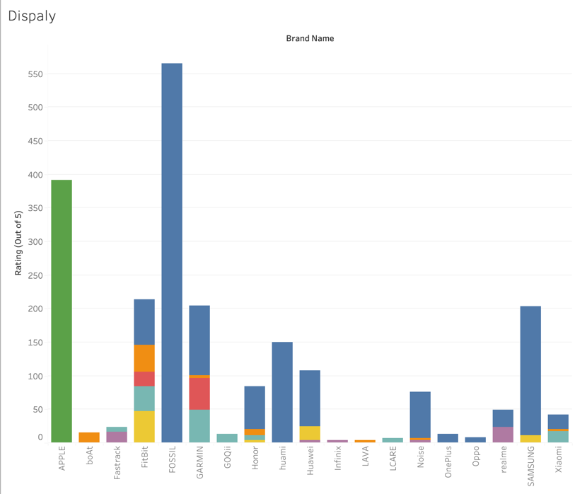

**Question 2:** What are the famous colours of the devices which are famous among the athletes?

This graph indicates the colours which have been used in most of the brands. As it will give us an idea of the most famous colour among the users according to the ratings. When it comes to fitness devices colour is considered one of the most key factors as there is a huge possibility that the device will end up getting dirt due to intense workouts and sweat.

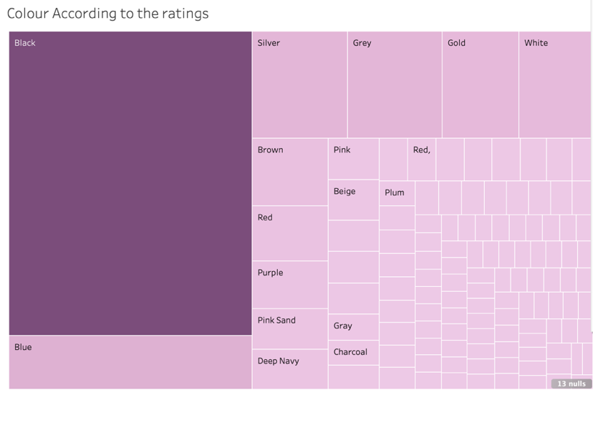

**Question 3:** What is the most affordable Fitbit device according to Jeremy’s budget?

This graph indicates the difference between the Selling price and the original prices of the Smartwatches of different models in Fitbit. By looking at this graph the customers will be able to get a clear idea of what model is much cheaper in Fitbit according to their budget if they are looking forward to going ahead with Fitbit.

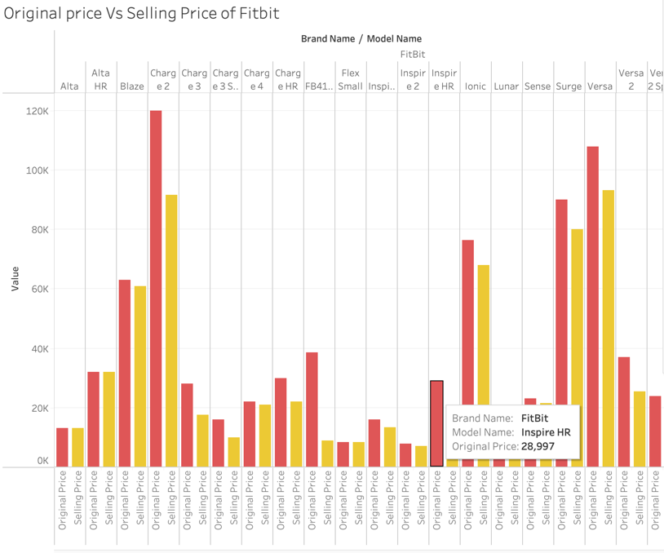

**Question 4: What** fitness tracker has the best average battery life as he is willing to wear the tracker throughout the day?

This graph indicates the Average life battery in all the brands according to the number of reviews it has been received. Therefore, this will give an idea for the customers to decide which fitness tracker would be much worth it.

